S-frames

🧱 What Is S-frames?
# Source: AI Source: Provided by: [Data Path: Persons Table -> ID Column: 1, Name_En Column: Motasem Essam] -> From: [ChatGPT] on [1/16/2026]
S-frames in HDLC (High-Level Data Link Control) are Supervisory frames that play a key role in flow and error control but do not carry user data. They are used to manage the reliable transmission of I-frames.

HDLC Frame Types (Context)
# Source: AI Source: Provided by: [Data Path: Persons Table -> ID Column: 1, Name_En Column: Motasem Essam] -> From: [ChatGPT] on [1/16/2026]
HDLC frames are divided into three types:
- I-frames (Information frames) – carry user data + control info
- S-frames (Supervisory frames) – flow and error control (no user data)
- U-frames (Unnumbered frames) – link management (setup, disconnect, mode changes)

What S-frames Do
# Source: AI Source: Provided by: [Data Path: Persons Table -> ID Column: 1, Name_En Column: Motasem Essam] -> From: [ChatGPT] on [1/16/2026]
- Acknowledge received I-frames
- Request retransmission of missing or erroneous I-frames
- Control the flow to prevent the sender from overwhelming the receiver
S-frames never carry actual user data, only control information.

Types of S-frames
# Source: AI Source: Provided by: [Data Path: Persons Table -> ID Column: 1, Name_En Column: Motasem Essam] -> From: [ChatGPT] on [1/16/2026]
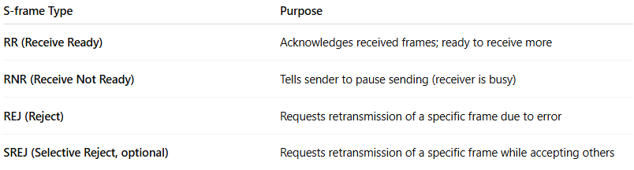
S-frame Type | Purpose
RR (Receive Ready) | Acknowledges received frames; ready to receive more
RNR (Receive Not Ready) | Tells sender to pause sending (receiver is busy)
REJ (Reject) | Requests retransmission of a specific frame due to error
SREJ (Selective Reject, optional) | Requests retransmission of a specific frame while accepting others

Structure of an S-frame
# Source: AI Source: Provided by: [Data Path: Persons Table -> ID Column: 1, Name_En Column: Motasem Essam] -> From: [ChatGPT] on [1/16/2026]
An S-frame includes:
- Address field – identifies the destination station
- Control field – contains:
  - Type of S-frame (RR, RNR, REJ, SREJ)
  - N(R): receive sequence number (acknowledgment)
  - P/F bit: poll/final bit for command/response control
- No information field (no user data)
- Frame Check Sequence (FCS) – error detection

Example Flow
# Source: AI Source: Provided by: [Data Path: Persons Table -> ID Column: 1, Name_En Column: Motasem Essam] -> From: [ChatGPT] on [1/16/2026]
- Sender transmits I-frames 0–3
- Receiver receives frames 0–2, misses frame 3
- Receiver sends REJ with N(R)=3 → request retransmission of frame 3
- Sender retransmits frame 3
This ensures reliable and ordered delivery.

Key Points
# Source: AI Source: Provided by: [Data Path: Persons Table -> ID Column: 1, Name_En Column: Motasem Essam] -> From: [ChatGPT] on [1/16/2026]
- S-frames are lightweight supervisory messages
- They control data flow and handle errors without carrying data
- Essential for reliable communication in HDLC and similar protocols (like LAPB in X.25)

In Simple Terms
# Source: AI Source: Provided by: [Data Path: Persons Table -> ID Column: 1, Name_En Column: Motasem Essam] -> From: [ChatGPT] on [1/16/2026]
S-frames are the “traffic controllers” of HDLC: they tell the sender which frames were received, which need to be resent, and whether to slow down or pause sending.

